OS Assignment-09

Jeetu Mehra
U24AI032

Question 1 : Write a C program to implement Banker’s Algorithm and determine whether
the system is in a safe state.
Expected Answer:
Student should write a program that:
• Takes n processes and m resources
• Inputs Allocation, Max, Available
• Computes Need
• Applies Safety Algorithm
• Prints safe sequence or unsafe state

Code:
#include <stdio.h>

int main() {
int n, m;

printf("Enter number of processes: ");
scanf("%d", &n);

printf("Enter number of resources: ");
scanf("%d", &m);

int alloc[n][m], max[n][m], need[n][m];
int avail[m];

// Allocation matrix
printf("Enter Allocation Matrix:\n");
for(int i=0;i<n;i++)
for(int j=0;j<m;j++)
scanf("%d",&alloc[i][j]);

// Max matrix
printf("Enter Max Matrix:\n");
for(int i=0;i<n;i++)
for(int j=0;j<m;j++)
scanf("%d",&max[i][j]);

// Available
printf("Enter Available Resources:\n");
for(int i=0;i<m;i++)
scanf("%d",&avail[i]);

// Need = Max - Allocation
for(int i=0;i<n;i++)
for(int j=0;j<m;j++)
need[i][j] = max[i][j] - alloc[i][j];

int finish[n], safeSeq[n];
for(int i=0;i<n;i++) finish[i] = 0;

int count = 0;

while(count < n) {
int found = 0;

for(int i=0;i<n;i++) {
if(finish[i] == 0) {
int j;
for(j=0;j<m;j++) {
if(need[i][j] > avail[j])
break;
}

if(j == m) {
for(int k=0;k<m;k++)
avail[k] += alloc[i][k];

safeSeq[count++] = i;
finish[i] = 1;
found = 1;
}
}
}

if(found == 0) {
printf("System is NOT in safe state\n");
return 0;
}
}

printf("System is in SAFE state\nSafe sequence: ");
for(int i=0;i<n;i++)
printf("P%d ", safeSeq[i]);

return 0;
}

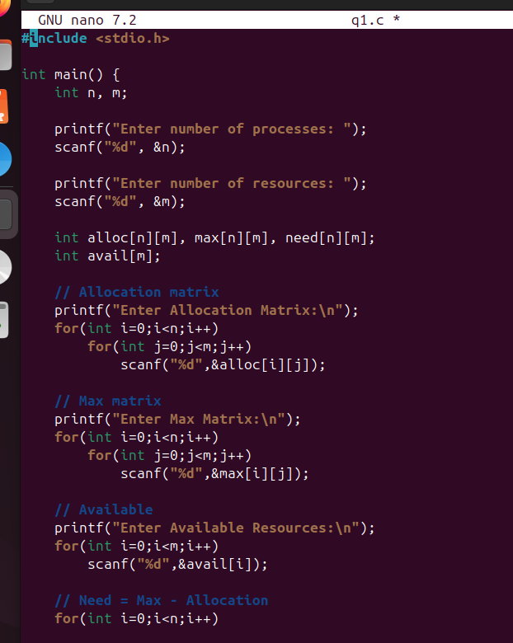

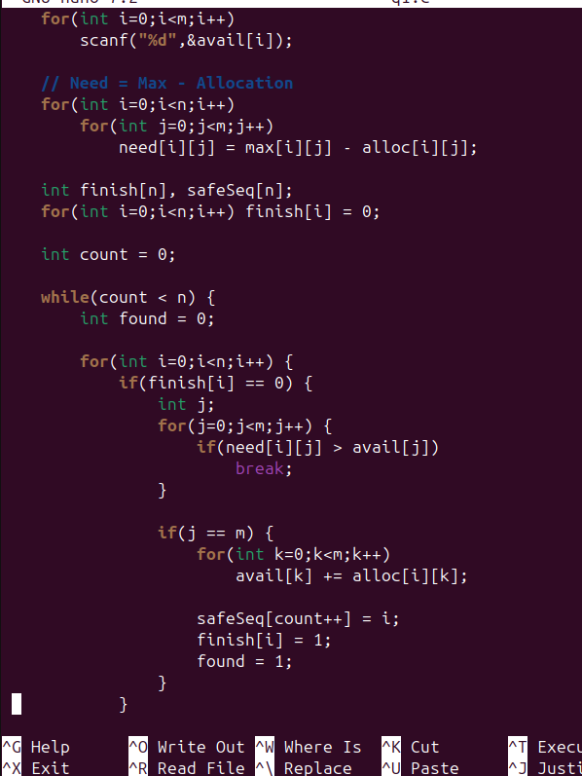
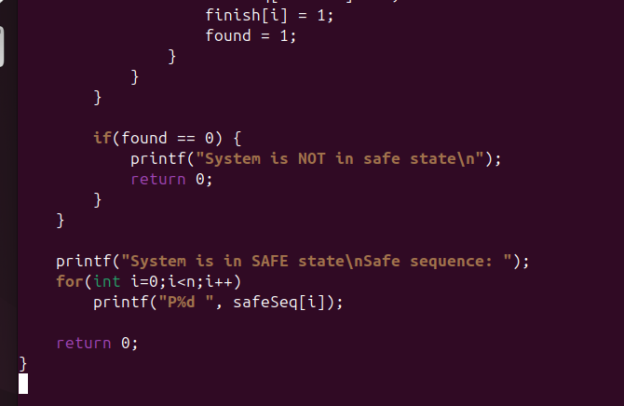

Output:
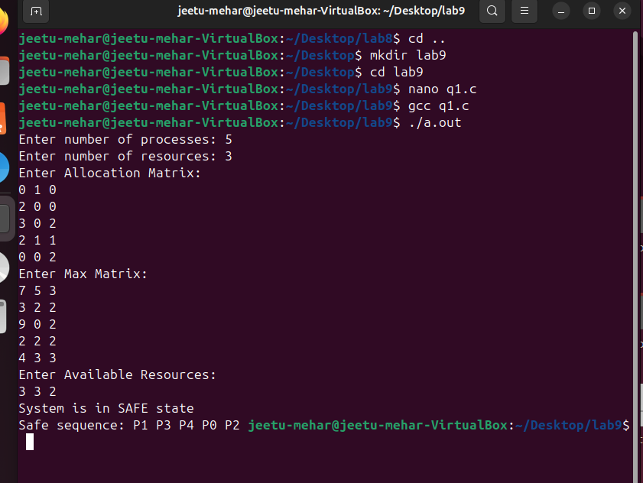

Question 2 : Modify the Banker’s Algorithm program to also process a resource request
from a process.
Expected Answer:
Program should:
• Take process number and request vector
• Check:
o Request &lt;= Need
o Request &lt;= Available
• Temporarily allocate
• Run safety algorithm
• Grant or deny request
Code:
#include <stdio.h>

int main() {
int n = 5, m = 3;

int alloc[5][3] = {
{0,1,0},
{2,0,0},
{3,0,2},
{2,1,1},
{0,0,2}
};

int max[5][3] = {
{7,5,3},
{3,2,2},
{9,0,2},
{2,2,2},
{4,3,3}
};

int avail[3] = {3,3,2};

int need[5][3];

// Calculate Need
for(int i=0;i<n;i++)
for(int j=0;j<m;j++)
need[i][j] = max[i][j] - alloc[i][j];

int process;
int request[3];

printf("Enter process number (0-4): ");
scanf("%d", &process);

printf("Enter request (3 values): ");
for(int i=0;i<m;i++)
scanf("%d", &request[i]);

// Step 1: Request <= Need
for(int i=0;i<m;i++) {
if(request[i] > need[process][i]) {
printf("Error: Request exceeds Need\n");
return 0;
}
}

// Step 2: Request <= Available
for(int i=0;i<m;i++) {
if(request[i] > avail[i]) {
printf("Resources not available. Wait.\n");
return 0;
}
}

// Step 3: Temporary allocation
for(int i=0;i<m;i++) {
avail[i] -= request[i];
alloc[process][i] += request[i];
need[process][i] -= request[i];
}

// Safety Algorithm
int finish[5] = {0};
int safeSeq[5];
int work[3];

for(int i=0;i<m;i++)
work[i] = avail[i];

int count = 0;

while(count < n) {
int found = 0;

for(int i=0;i<n;i++) {
if(!finish[i]) {
int j;
for(j=0;j<m;j++) {
if(need[i][j] > work[j])
break;
}

if(j == m) {
for(int k=0;k<m;k++)
work[k] += alloc[i][k];

safeSeq[count++] = i;
finish[i] = 1;
found = 1;
}
}
}

if(!found) {
printf("Request cannot be granted (Unsafe state)\n");
return 0;
}
}

printf("Request granted!\nSafe sequence: ");
for(int i=0;i<n;i++)
printf("P%d ", safeSeq[i]);

return 0;
}
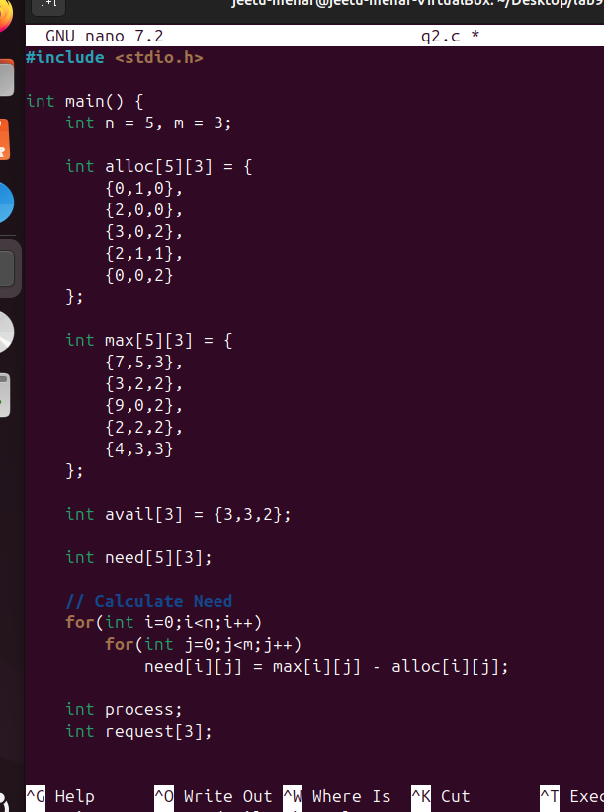
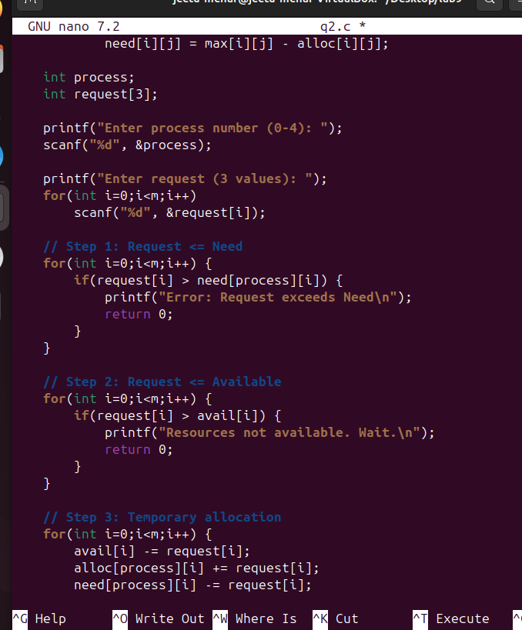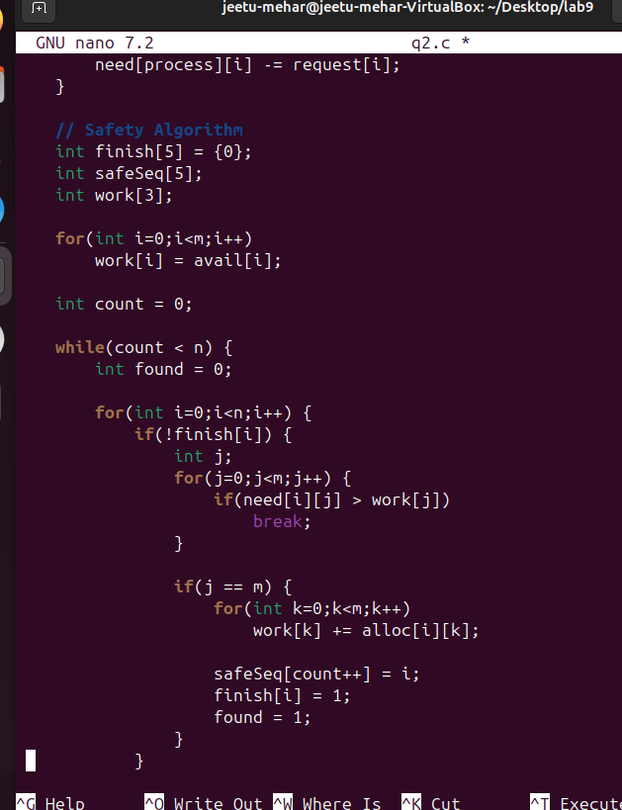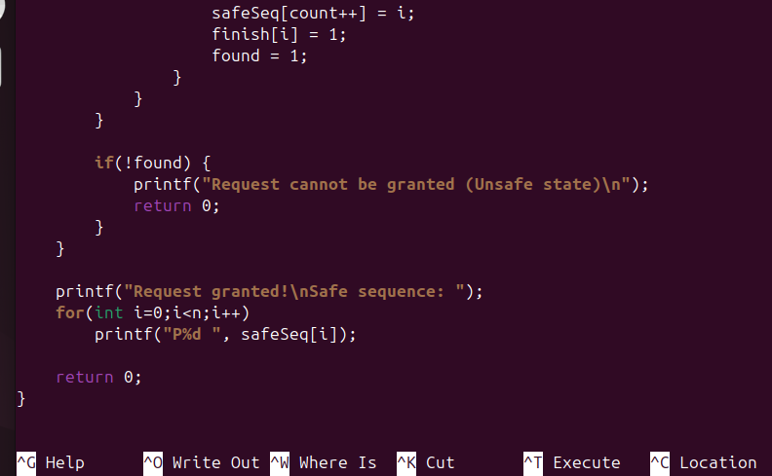

Output:
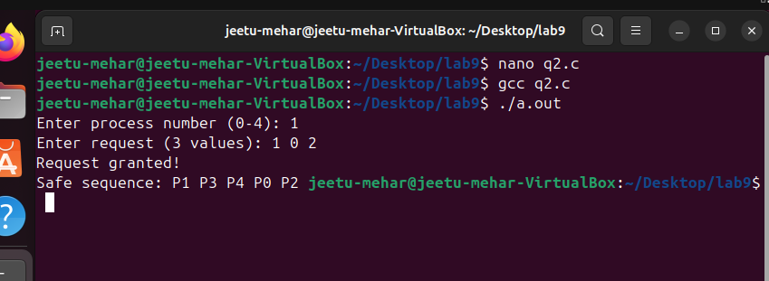
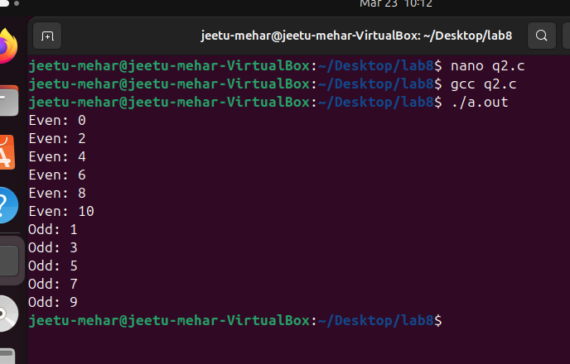

Question 3 : Write a program to display all matrices used in Banker’s Algorithm in tabular
format.
Expected Answer:
Should print:
• Allocation
• Max
• Need
• Available
Code:
#include <stdio.h>

int main() {
int n = 5, m = 3;

int alloc[5][3] = {
{0,1,0},
{2,0,0},
{3,0,2},
{2,1,1},
{0,0,2}
};

int max[5][3] = {
{7,5,3},
{3,2,2},
{9,0,2},
{2,2,2},
{4,3,3}
};

int avail[3] = {3,3,2};

int need[5][3];

// Calculate Need
for(int i=0;i<n;i++)
for(int j=0;j<m;j++)
need[i][j] = max[i][j] - alloc[i][j];

// Display Table
printf("\nPROCESS\tALLOCATION\tMAX\t\tNEED\n");

for(int i=0;i<n;i++) {
printf("P%d\t", i);

// Allocation
for(int j=0;j<m;j++)
printf("%d ", alloc[i][j]);

printf("\t\t");

// Max
for(int j=0;j<m;j++)
printf("%d ", max[i][j]);

printf("\t\t");

// Need
for(int j=0;j<m;j++)
printf("%d ", need[i][j]);

printf("\n");
}

// Available
printf("\nAvailable: ");
for(int i=0;i<m;i++)
printf("%d ", avail[i]);

printf("\n");

return 0;
}
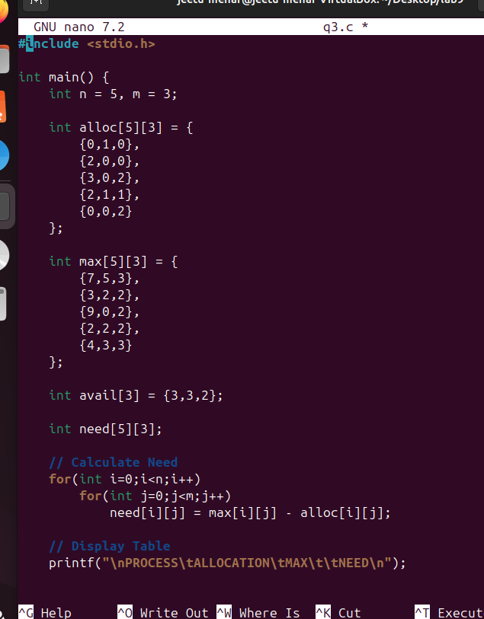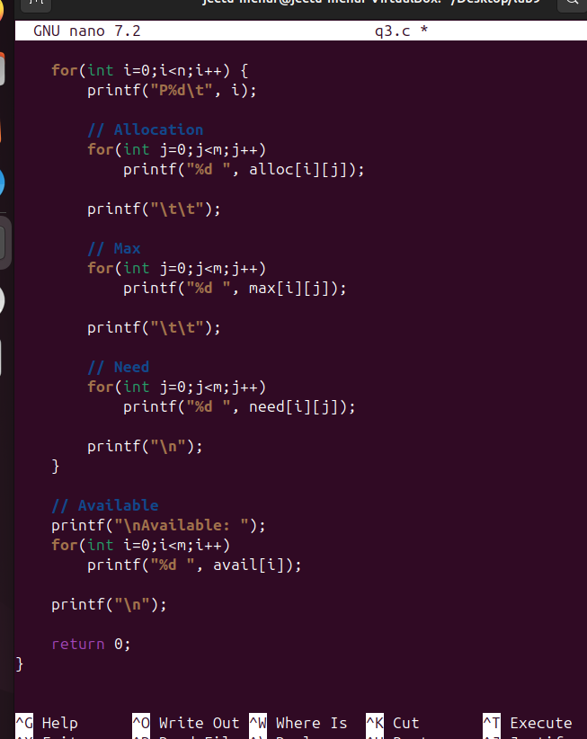

Output:

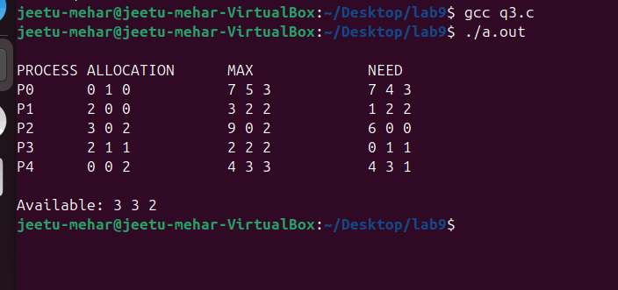

Question 4 : Write a menu-driven C program for Banker’s Algorithm with options:
1. Enter data
2. Display Need matrix
3. Check safe state
4. Process resource request
5. Exit

Code:
#include <stdio.h>

#define MAX 10

int n, m;
int alloc[MAX][MAX], max[MAX][MAX], need[MAX][MAX];
int avail[MAX];

void calculateNeed() {
for(int i=0;i<n;i++)
for(int j=0;j<m;j++)
need[i][j] = max[i][j] - alloc[i][j];
}

void inputData() {
printf("Enter number of processes: ");
scanf("%d", &n);

printf("Enter number of resources: ");
scanf("%d", &m);

printf("Enter Allocation Matrix:\n");
for(int i=0;i<n;i++)
for(int j=0;j<m;j++)
scanf("%d",&alloc[i][j]);

printf("Enter Max Matrix:\n");
for(int i=0;i<n;i++)
for(int j=0;j<m;j++)
scanf("%d",&max[i][j]);

printf("Enter Available Resources:\n");
for(int i=0;i<m;i++)
scanf("%d",&avail[i]);

calculateNeed();
}

void displayNeed() {
printf("\nNeed Matrix:\n");
for(int i=0;i<n;i++) {
for(int j=0;j<m;j++)
printf("%d ", need[i][j]);
printf("\n");
}
}

void checkSafeState() {
int work[MAX], finish[MAX]={0}, safeSeq[MAX];

for(int i=0;i<m;i++)
work[i] = avail[i];

int count = 0;

while(count < n) {
int found = 0;

for(int i=0;i<n;i++) {
if(!finish[i]) {
int j;
for(j=0;j<m;j++) {
if(need[i][j] > work[j])
break;
}

if(j == m) {
for(int k=0;k<m;k++)
work[k] += alloc[i][k];

safeSeq[count++] = i;
finish[i] = 1;
found = 1;
}
}
}

if(!found) {
printf("System is NOT in safe state\n");
return;
}
}

printf("System is in SAFE state\nSafe sequence: ");
for(int i=0;i<n;i++)
printf("P%d ", safeSeq[i]);
printf("\n");
}

void requestResources() {
int process, request[MAX];

printf("Enter process number: ");
scanf("%d",&process);

printf("Enter request:\n");
for(int i=0;i<m;i++)
scanf("%d",&request[i]);

// Check Request <= Need
for(int i=0;i<m;i++) {
if(request[i] > need[process][i]) {
printf("Error: Request exceeds Need\n");
return;
}
}

// Check Request <= Available
for(int i=0;i<m;i++) {
if(request[i] > avail[i]) {
printf("Resources not available\n");
return;
}
}

// Temporary allocation
for(int i=0;i<m;i++) {
avail[i] -= request[i];
alloc[process][i] += request[i];
need[process][i] -= request[i];
}

printf("Request granted (if safe)\n");
checkSafeState();
}

int main() {
int choice;

while(1) {
printf("\n--- Banker Menu ---\n");
printf("1. Enter Data\n");
printf("2. Display Need Matrix\n");
printf("3. Check Safe State\n");
printf("4. Process Resource Request\n");
printf("5. Exit\n");

printf("Enter choice: ");
scanf("%d",&choice);

switch(choice) {
case 1: inputData(); break;
case 2: displayNeed(); break;
case 3: checkSafeState(); break;
case 4: requestResources(); break;
case 5: return 0;
default: printf("Invalid choice\n");
}
}
}
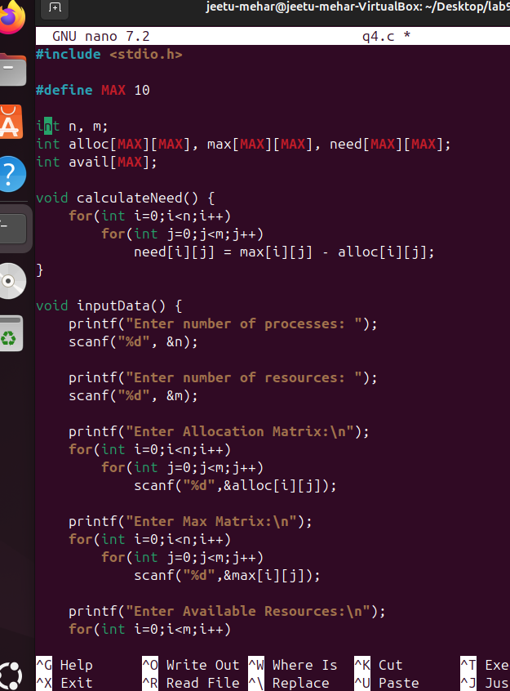
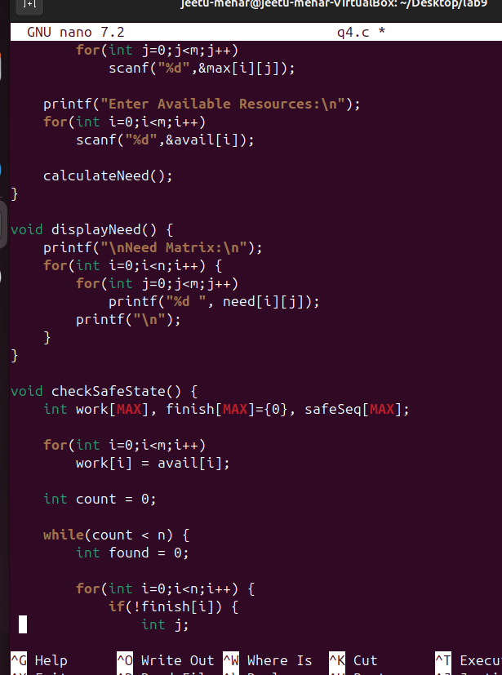
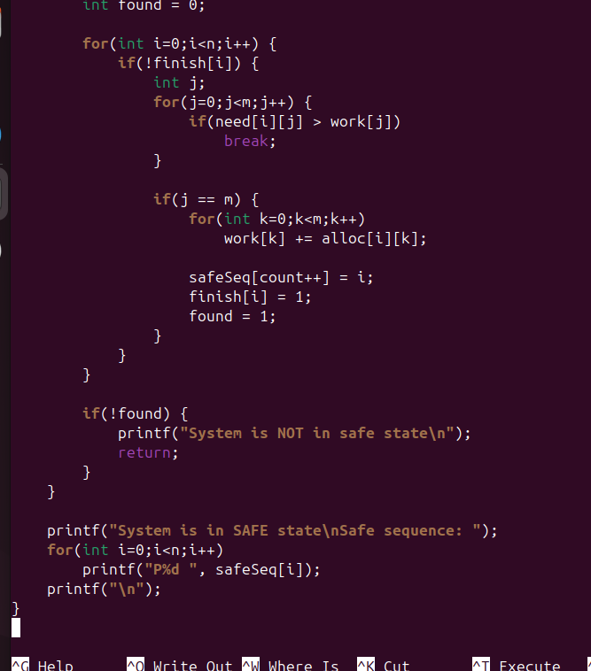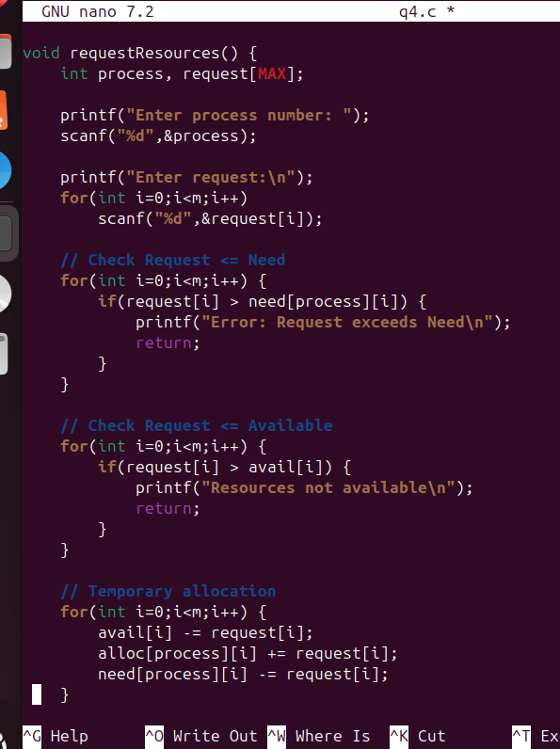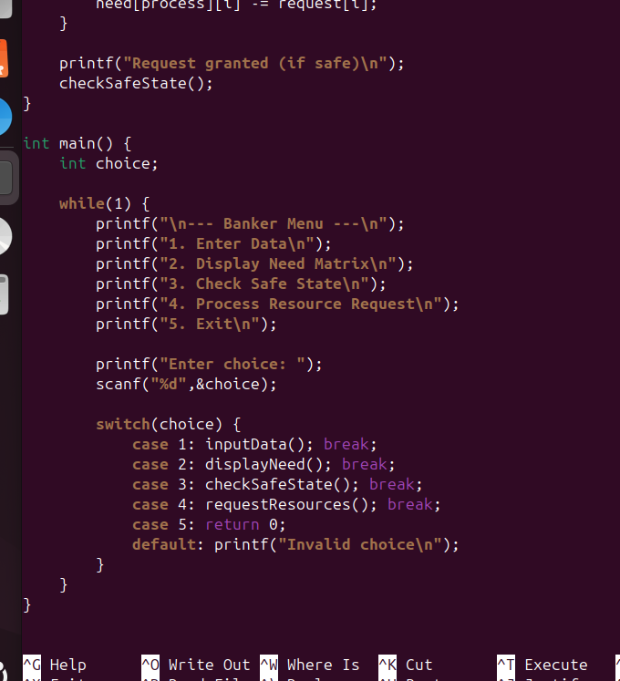

Output:

